1. Launch one Linux instance in aws.

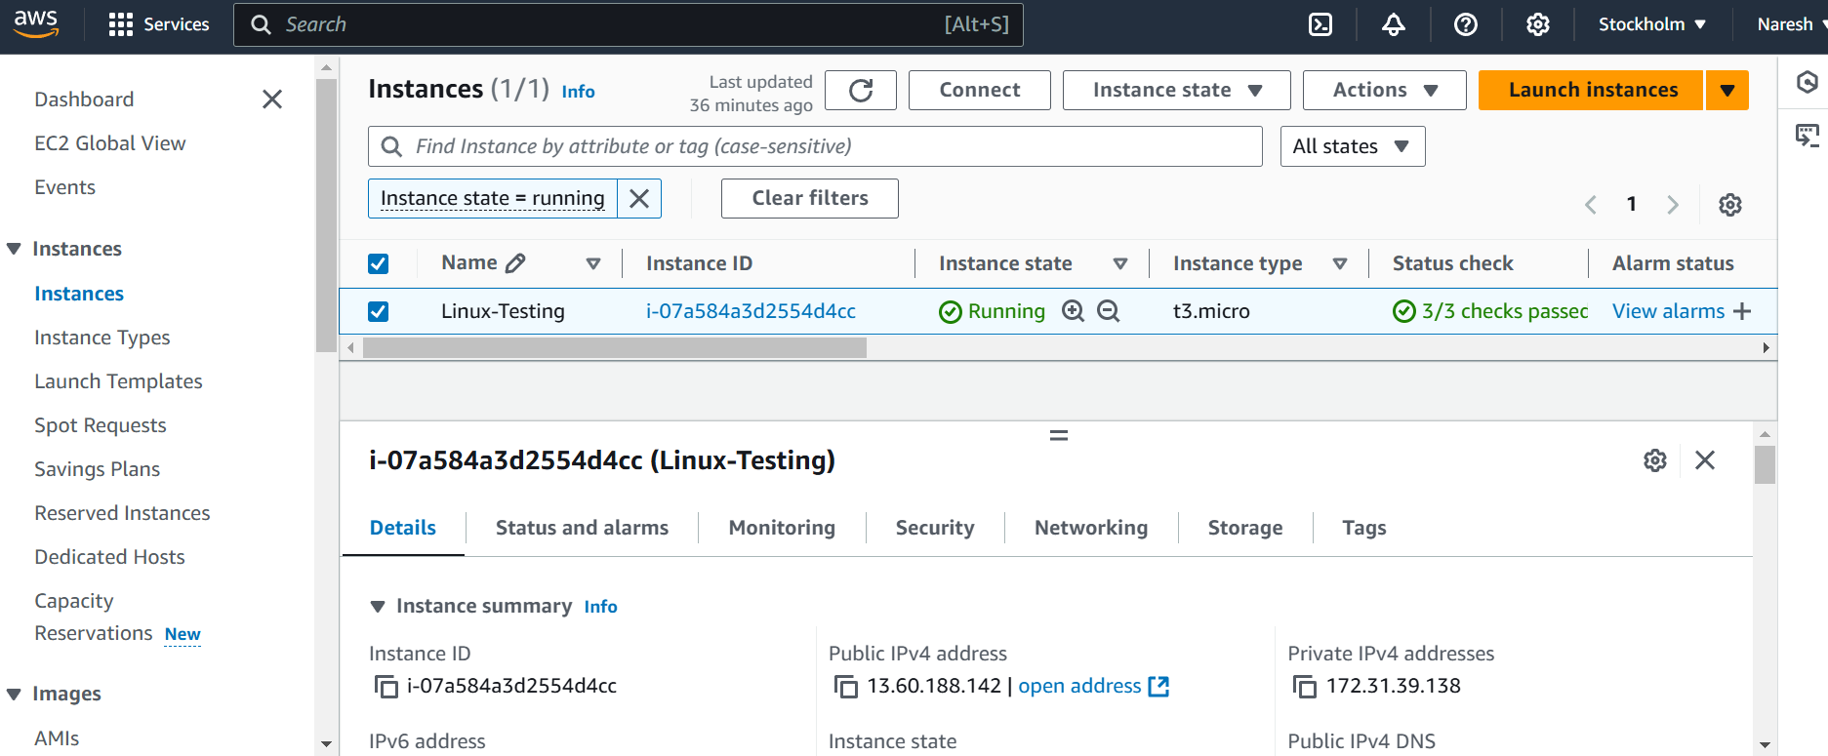

2.Create on file with name Techie_horizon

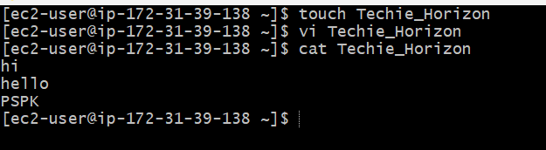

3.Copy the file "Techie_Horizon" from aws instance to windows machine



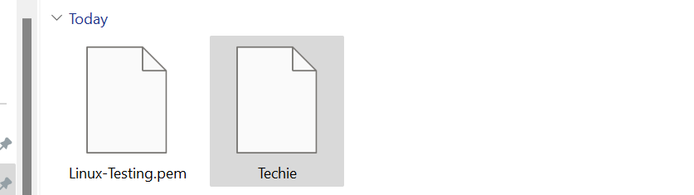

4.Install Jenkins in the server created in step 1.

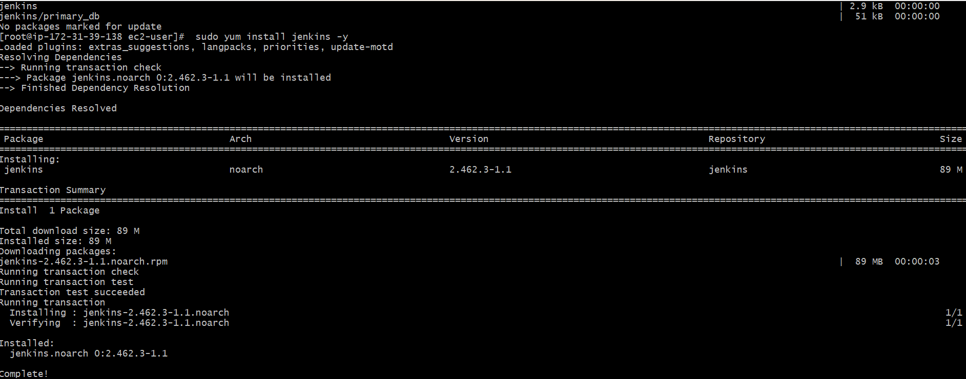

5.Install httpd,nginx,Apache Tomcat.

